**Experiment 1:-** Design a LED Flasher

**Circuit Diagram:-**

**Theory:-**

**Concept used:-**

The concepts I used are as follows:-

1)The arduino board can supply a power of 5v as digital output signals through the 14 pins and are used as +ve terminal and GND pin is used as –ve terminal.

2)In the bread board present in the above circuit diagram. The connection pattern is shown below: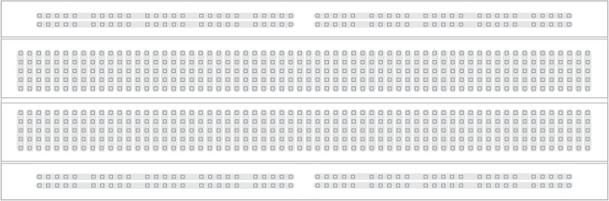

**Learning and Observation:-**

**Leanings:**

1. I learned how to make a series circuit using an arduino board.
2. I learned about how an arduino works.
3. I have now gained a experience of how an LED and a resistor work.
4. I also learned how current flows and how it works.

**Observations:-**

1. When we pass electrical signals to the arduino the LED glow and gets off accordingly.

**Problems and Troubleshooting:-**

The LED bulb wasn’t working because it was short. So I had to replace it with new ones.

**Precautions:-**

The precautions we need to take are as follows:-

1) The connections at different points should not be loose and the pins should be inserted properly.

1. The two pins of the LED should be connected at their appropriate point that is the positive point should be connected with the p pin and the negative point should be connected with the negative pin.
2. We should take care that the circuit is closed .

**Learning Outcomes:-**

* I learned how to make circuits using an arduino board.
* I gained the skill of making a circuit using different hard wares and controlling the functions done by that circuit with the help of codes.